Have created a table titanic and have loaded the data into it.

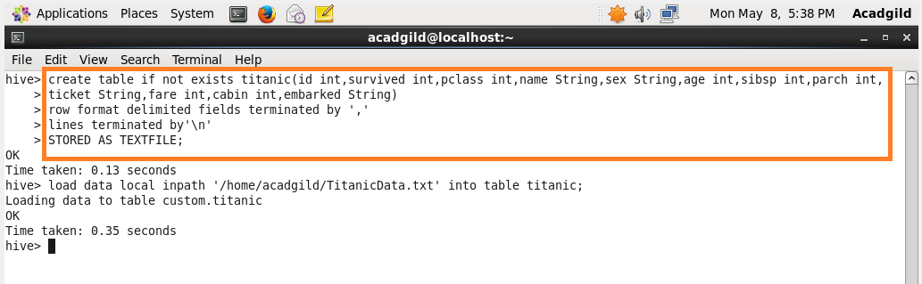

1.Write a hive query find the average age of male and female persons died in the titanic tragedy

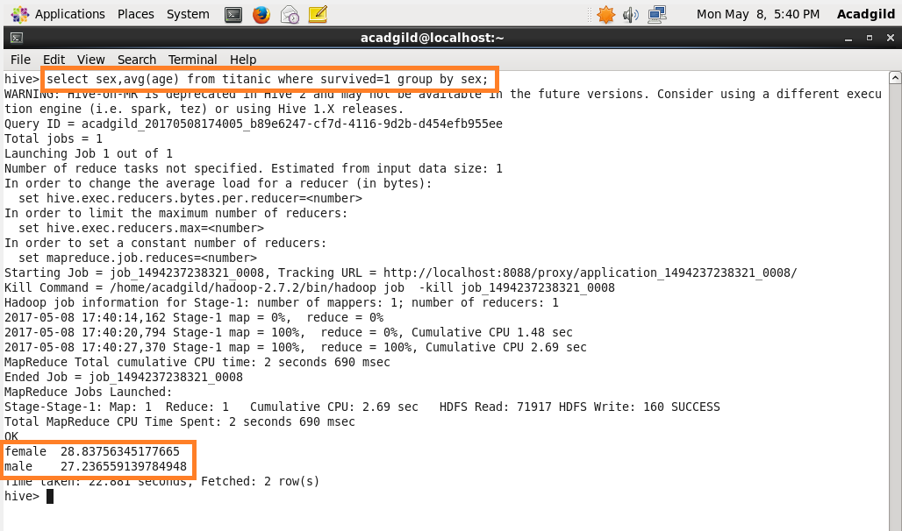

2.Write a hive query to find the number of people died and survived in each class

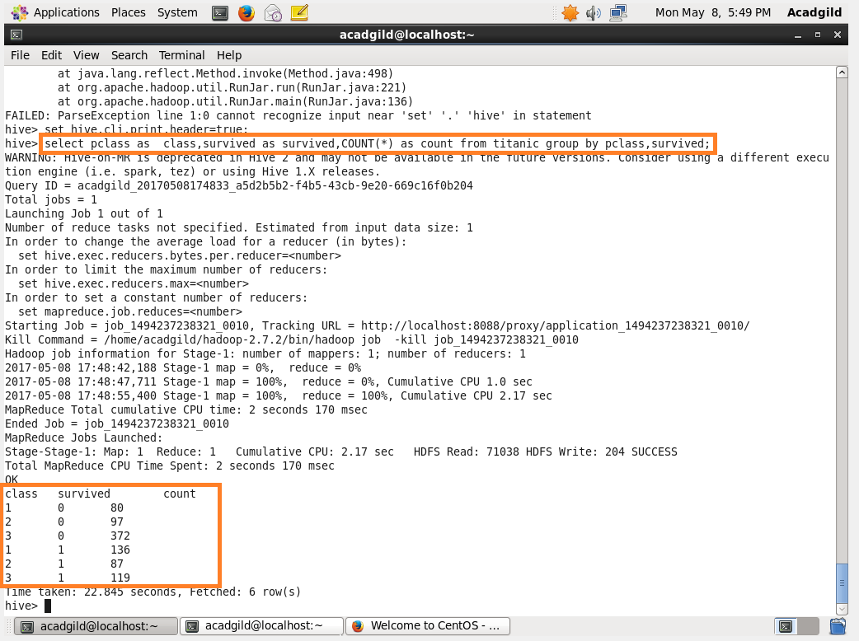

Here ‘0’ in survived refer to the passenger who survived and ‘1’ refers to the passenger who died.